**Problem** Statement

Flight delay is one of the most remembered performance indicator of any transportation system. Kevin wants to travel from Seattle to Barcelona for a very important business meeting, he books the ticket with one the of Airline companies. He reaches to the Airport on the day of his flight and finds that the flight with which he was supposed to travel will be delayed or cancelled and came to know that the Airline company with which he booked the ticket is having bad records of flight delay. Another reason for the delay was bad weather. Such kind of situation may put a person into a trouble to avoid such situations Machine Learning service of Azure could be used.

# **Solution**

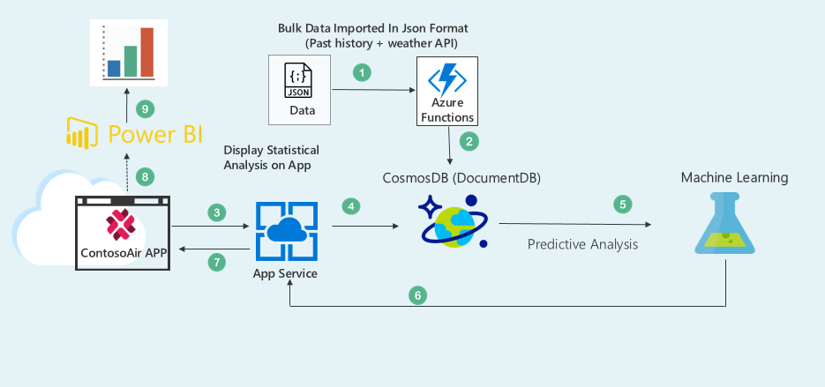

# **Workflow**

1. Bulk data will be imported through Azure Functions into CosmosDB in JSON format.

**Note:**  Bulk data includes the data retrieved from weather API and airlines past history data of delay and

cancellation.

1. Request generated to view the flight status will be sent through ContosoAir App which is hosted on App service.
2. Data will be retrieved from CosmosDB which will be then sent to Machine learning service for Predictive Analysis.
3. Using ContosoAir website user can view the analytical report generated through Power BI.

* Before booking a ticket.
* After booking a ticket.

# **User story**

|  |  |
| --- | --- |
| 1 | **Scenario walkthrough – ContosoAir Website**   1. Kevin goes to ContosoAir website. 2. He selects the Source - Destination and Airline with which he wants to travel. 3. And will check the past delay/cancellation history of that Airline with Destination on clicking the option provided to view the status. 4. On getting positive results after analyzing the past delay/cancellation history status, he will book the ticket with that Airline. 5. He can even get the flight delay/cancellation status a day before boarding his flight. 6. By clicking on View flight status button present on the ContosoAir website. |
| 2 | **Scenario walkthrough – CosmosDB (DocumentDB API)**   1. After clicking on the View flight status button, it will fetch the data from CosmosDB (DocumentDB API). 2. Data present in the CosmosDB (DocumentDB API) will be fetched in JSON format and processed through Azure Functions. |
| 3 | **Scenario walkthrough – Machine Learning**   1. Fetched data from the CosmosDB (DocumentDB API) will be processed through machine learning. 2. Machine learning service will give the predictive analysis for flight delay, cancellation depending on past history data. |
| 4 | **Scenario walkthrough – Power BI**   1. Delay prediction or flight cancellation analytics will be displayed through Power BI. 2. On clicking the URL present on ContosoAir website it redirects the user on the page of analytics generated through Power BI. |

# **Platform**

Website

# **Technology Used**

**DocumentDB:** DocumentDB is Microsoft's newest NoSQL document database platform that runs on Azure. DocumentDB is designed keeping in mind the requirements of managing data for latest applications.

**Machine Learning:** Predictive analysis is done by machine learning service with the help of DocumentDB database.

**PowerBI:** It generates the analytics depending on the result of Machine learning module.